How to check a variable’s type?

Vào interactive mode rồi dùng chế độ type.

VD: 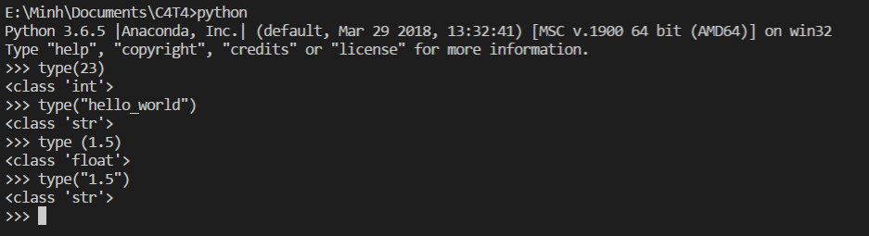

In what cases, you will get ***SyntaxError*** from the compiler telling you that some of your variables have **invalid names**? Can you give 3 different examples of **invalid names**?

Khi dùng text mà không cho vào trong dấu quotation